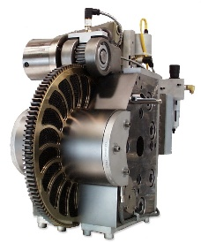 QUICK QUOTE
By providing the below –mentioned parameters, Patt Technologies can give you a preliminary filter system quotation. It`s quick, simple and free.
Company Name:
Contact Name:
Telephone No:
E-mail:

PLEASE COMPLETE THESE 3 SIMPLE STEPS.
- STEP 1 Throughput

What is the average throughput of the line on witch our filtration system be installed?
_________________ lbs/hr kg/hr

- STEP 2 Pressure Levels

What are the typical pressure levels on this line before and after the screenchanger?

Before__________ PSI BAR

After __________ PSI BAR
- STEP 3 Polymer & Process Type

Which process are you using and which polymer are you processing?

Process Type: _____________
Polymer Type: _____________

Additional Information
If you have any additional information that will help us select you filtration system, let us know.
____________________________________________________________________________________
_____________________________________________________________________________________
_____________________________________________________________________________________

NAME: __ DATE: _
PATT TECHNOLOGIES (Div. of 8315558 Canada Inc.)

588 Boul. Industriel, St-Eustache, QC, J7R-5V3 Canada Tel : 450-689-2497 Fax : 450-689-2972
Email : Sales@patt-tech.com

